This report has three parts: a report of the distribution of data held outside the EOS Core System (ECS), a report of statistics for data held by ECS, and tables, text and graphs combining the statistics available for both groups of data.

Summary

For FY2002, the total number of accesses to the EOSDIS data systems was 4,954,794.

The total number of distinct users, including Web hits as defined by the user email address, was 2,198,452.

The total number of products delivered was 19,366,334. The total volume of data delivered was 378,770,053 MB. For ECS data, one "product" is one granule of data. For data held outside ECS, a "product" is the smallest physically or logically indivisible orderable/deliverable unit of data.

The average delivery time for all data held outside ECS was 1 day. This includes data retrieved via anonymous FTP or via the WWW, which are received by the user immediately. For the reporting period, the majority of ECS deliveries is via FTP and therefore took less than one day. The average delivery time from ECS for media has not been computed because of insufficient data and inconsistent time references.

The total number of repeat users requesting or retrieving data is79,130, out of 217,626 users requesting or retrieving data. Repeat users are users who have ordered/received data on more than one date since the start of the statistics collection system with at least one order/receipt during FY2002. The graph of repeat users does not include data for fiscal years before FY2000.

This report contains tables of FY2002 statistics and graphs comparing FY2002 statistics to previous years and projections for future years. Additional information can be found in the following text and the report tables.

Report of Data Held Outside ECS:

The report of data held outside ECS includes statistics for all pre-Earth Science Enterprise (ESE) data, TRMM data, and QuikSCAT data. Terra CERES data delivered before July 1, 2002 is reported here because it is processed by LaTIS, which was already reporting TRMM CERES data. The report period is October 1, 2001 through September 30, 2002.

Report of Data held by ECS

The report of data held by ECS includes statistics for Landsat 7 and Terra data except for Terra CERES data. Terra CERES data delivered after June 30, 2002 is included in this report. Earlier Terra CERES data deliveries are included in the Report of Data Held Outside ECS. The report period is October 1, 2001 through September 30, 2002.

It includes the following tables and graphs:
- Data Ingested by Instrument - number of granules and total volume by instrument and DAAC
- Data Archived by Instrument - number of granules and total volume by instrument and DAAC
- Data Retrieved from Archive - number of granules and total volume by instrument and DAAC
- Distribution to Users - total numbers of orders, requests, granules, files, and total megabytes by DAAC
- Graph of the Top 10 Data Types

Combined Report:

The combined report contains plots, tables, and explanatory text for the statistics on all data distribution to users, since only distribution statistics are collected for data held outside ECS.

Note that for FY00, the statistics on data held by ECS are reported for February 24, 2000 (lens cap off) through September 30, 2000. All other data is reported for fiscal years beginning October 1 and ending September 30.

DEFINITIONS:

Number Of Distinct Users Accessing DAACs:

Distinct means that each unique user is counted exactly one time for the report period. Two different methods are used to determine a distinct user.

The statistics for data held outside ECS determine user identity using the email address. Each unique email address determines a distinct user. If the same email address requests two products, it is reported as one distinct user and as two products delivered. One person can use two different email addresses or two people can use the same email address, but addresses are the only user information available. Users accessing by more than one method or DAAC will be counted for each method and DAAC.

The ECS statistics system uses the user last name as well as the email address to determine a unique user. This is necessary because all user requests for Landsat data at EDC are turned into level 0 requests that are sent to a single email address within EDC.

All accesses to ECS are currently through the EOS Data Gateway (EDG) in order to request data. Those accesses are included in the statistics data reported for data held outside ECS so the total number reported is all users of both systems as determined by email address. Because of the different information available to the two systems, the resulting counts of users cannot be accurately added together or subtracted from each other.

The Total Number of Distinct Users is the sum of the following user categories:

EDG = EOS Data Gateway, including accesses to non-ECS systems and ECS.

Local IMS = local Character User Interface (ChUI) and local Graphical User Interface (GUI) for DAACs that have one

WWW = distinct addresses or user host machine identification per DAAC for the report period. Note that, for the most part, only user host machine identification is available. This includes WAIS logs. This includes general accesses to Web pages maintained at the DAACs. These are users getting general DAAC information as well as users accessing the pages for DAAC catalogs and data.

FTP = distinct addresses per DAAC for the report period.

Off-line = the number of off-line inquiries received. The number of distinct users is not available, but this was added to provide consistency between the items reported under distinct users and number of accesses.

Number Of Accesses:

This is the total number of accesses to data held outside ECS or in ECS systems. Users accessing any system multiple times or by more than one method or DAAC will be counted for each method or DAAC.

All accesses to ECS are currently through the EOS Data Gateway (EDG) in order to request data and cannot be separated from accesses to EDG for data held outside ECS data. There is no separate reporting of accesses (distinguished from data orders) within ECS.

There are several methods of accessing data held outside the ECS data. A description of the computation of accesses for each is:

EDG = a count of all sessions reported by the EOS Data Gateway, including those accessing ECS.

Local IMS = a count of all local ChUI and/or local GUI sessions for the report period, for DAACs that have them.

WWW Inquiries = the sum, over one report period, of the number of distinct users for each day of the report period. This includes WAIS logs. Multiple accesses by the same email address or host on the same day will be counted as one access. This includes general accesses to Web pages maintained at the DAACs. Accesses by the same email address or host to two different Web sites at the same DAAC will be counted as two accesses.

WWW Data Retrievals = the sum, over one report period, of the number of distinct users for WWW data retrieval for each day of the report period. Multiple accesses by the same email address or host on the same day will be counted as one access.

FTP = the sum, over one report period, of the number of distinct users for each day of the report period. Multiple accesses by the same email address or host on the same day will be counted as one access.

Off-line = a count of all inquiries made through user services personnel or non-automated methods (phone, mail, email, fax, walk-in). Inquiries can be general, about documentation ordering, data and software questions, system usage, requests for inventory searches, or result in referrals to other DAACs or organizations.

Number of Products Delivered:

The number of products delivered is the number of product requests that are identified as completed, or closed and accepted but not completed during the report period. This includes data deliveries on media and data files retrieved by the user via FTP or WWW.

For ECS, one product is one granule of data. Each product may be delivered to the user either on media or via FTP push or FTP pull. The reported number of products and volume delivered from ECS was calculated differently for FY02 than for previous years. The earlier calculation of total products delivered included end users, QA, test, and production. The FY02 total products delivered includes only those products know to be delivered to end users via orders or subscriptions. It is not possible to accurately recalculate the FY01 and FY00 totals. The chart of volumes delivered shows a drop in total volume delivered because of this calculation change.

A product is the smallest physically or logically indivisible orderable/deliverable unit, regardless of how many pieces end up constituting the item. An example of a physically indivisible unit is a CD-ROM. An example of a logically indivisible unit would be a set of files that are determined to be unusable except as a set.

FTP Product Retrievals = number of retrievals ("gets") determined from the anonymous FTP logs for the reporting period.

WWW Product Retrievals = number of WWW retrievals from the WWW logs determined by the DAAC to be actual data for the reporting period.

Volume of Products Delivered:

The volume of products delivered is the sum of volumes for all products delivered, in megabytes, for the report period. This includes data deliveries on media and data files retrieved by the user via FTP or the WWW. Volume units are converted from bytes or kilobytes to megabytes or gigabytes using factors of 1024 (Megabytes = Kilobytes/1024, Megabytes = Bytes/1048576, etc.).

Average Delivery Time:

The average delivery time is the average number of days from product request origination to shipping, for products delivered during the report period. The average used is a simple average, not a median, or other calculation.

For the reporting period, the majority of ECS deliveries are electronic and therefore took less than one day. The average delivery time from ECS for media has not been computed because not enough data is consistently available different time references are used.

For data held outside ECS, average delivery time is computed by summing the difference of the request and completion dates included in the SCRS data for media requests, then dividing by the sum of the number of products delivered via media plus data products retrieved via FTP or WWW. The delivery time for FTP or WWW data retrievals is assumed to be 0 days. Requests identified by the DAAC as subscriptions are not counted. When products are requested before they are available, the days are counted from the date the product became available. This is approximate because not all subscriptions are identified as such and product requests that pre-date the availability of the data do not all include that information in the statistics.

Repeat Users:

Repeat Users is a count of the number of distinct users who have ordered/received data on more than one date since the start of the statistics collection system. It is not deemed necessary to distinguish two orders in the same day as a repeat. The two definitions given for distinct users apply here as well.

Characterization of All Users Requesting Products:

User characterization counts each user exactly one time for the report period, based on unique email addresses, for each DAAC contacted. All users are those that have been reported in some previous report period plus those who are new for the report period.

The following user categories are reported separately in each of the user characterization tables:

US Government = all addresses ending in .gov or .mil and all addresses ending in .us and including .gov. or .mil. in the address.

Educational = all addresses ending in .edu or .k12 and all addresses ending in .us and including .edu. or .k12. in the address. These are US addresses.

Commercial = all addresses ending in .com, .bus and .net and all addresses ending in .us and including .com. or .net. in the address. These are US addresses.

Non-Profit = all addresses ending in .org and all addresses ending in .us and including .org. in the address. These are US addresses.

Other USA = all addresses ending in 3 letters after the decimal and all addresses ending in .us that are not in the other US categories.

Total US = US government + US educational + US commercial + US nonprofit + US other.

Foreign = all addresses ending in .xx, where .xx is not .us

Unknown = any address that does not fit into the above categories, as well as those that are numeric and cannot be parsed.

Total = the total users for the report period. Total Users = Total US + Foreign + Unknown

These are users who requested products from the DAACs, received files via anonymous FTP from the DAACs, or retrieved data files via WWW from the DAACs. This does not include those making inquiries, either off-line or via WWW, those accessing the DAACs via IMS but not requesting data, and those whose orders were placed before the beginning of the report period. Users using more than one method to obtain data are counted only once.

Characterization of New Users Requesting Products:

New users are those who have never been recorded by the statistics reporting system before this report period. This uses the same descriptions as the Characterization of All Users Requesting Products.

Characterization of Repeat Users Requesting Products:

Repeat users are distinct email addresses who have ordered/received data on more than one date. This uses the same descriptions as the Characterization of All Users Requesting Products.
This report contains statistics for distribution of EOSDIS data during fiscal year 2002, October 1, 2001 through September 30, 2002. Values for previous fiscal years are taken from previous SCRS/EDGRS Fiscal year summary reports.

Notes on the combined report:

- The EOS Data Gateway (EDG) is used to access data held in ECS and also outside the ECS. No way has been identified to separate the ECS and non-ECS accesses. EDG access statistics are reported under data held outside ECS but are not identified with individual sites. In the combined report, EDG accesses and users are included in the totals. The non-ECS system reports users based on unique email addresses. ECS contains both email addresses and user last names so ECS users can be identified by that combination.
- ECS does not report accesses to the system unless a product was requested. Since the only method of access to ECS is the EDG, the total accesses are given by the non-ECS total.
- The reported number of products and volume delivered from ECS was calculated differently for FY02 than for previous years. The earlier calculation of total products delivered included end users, QA, test, and production. The FY02 total products delivered includes only those products know to be delivered to end users via orders or subscriptions. It is not possible to accurately recalculate the FY01 and FY00 totals. The chart of volumes delivered shows a drop in total volume delivered because of this calculation change.
- LaRC requests and product deliveries through the LATIS system are recorded in the ECS system as of July 1, 2002. LATIS statistics were reported through the Non-ECS system until July 1, 2002.

Notes on data held outside the EOS Core System (ECS):

This report was generated in December 2002 from data received as of December 9, 2002. It is based on the data in the Statistics Collection and Reporting System (SCRS) data base tables, with some hand entry for GSFC, and GCMD. The format for the report is the same as was used for the September monthly report.
- FTP accesses is the sum, over the year, of distinct users per day for each FTP system.
- WWW accesses is the sum, over the year, of distinct users per day for each WWW system, whether it be a home page or data order site.
- Rejected = number rejected for DAAC error. It does not include cancellations or rejected for user error.
- Successful = completed + rejected for user error. Cancelled product requests are not counted as successful.
- User services personnel, developers, and testers are not included in the user counts. All addresses ending with the following hosts are included in the list of testers/developers: killians.gsfc.nasa.gov, killians-e.gsfc.nasa.gov, eos.hitc.com, harp.gsfc
- The user characterization report does not include local IMS users, WWW inquiry users, or off-line users making inquiries. It does include anonymous FTP users, customers requesting deliveries in the month of the report, and users retrieving data via WWW.
- Inconsistencies in the ASF volume delivered are due to reports of hard-copy (paper or film) products with non-zero volumes that are the volumes of the digitized data.
- NSIDC statistics do not include the volume delivered except via anonymous FTP.
- The EOS Data Gateway (EDG) is an interface to V0 IMS ordering systems and to ECS. The data reported here includes both accesses to V0 systems and to ECS. The data cannot be separated accurately.
- SEDAC offline product request, tracking and inquiry data has not been received since April 1998.
- ASF offline inquiry data has not been received since June 1999.
- LaRC FTP data have not been received in a usable format since August 1999. LaRC offline inquiry data has not been received since October 1999.
- The log for one of the SEDAC Web servers was lost from November 13 to December 12, 2001.
- NSIDC FTP log statistics for July 12 to August 1, 2002 were lost because of an error at NSIDC.
- These notes list the data known to be unavailable for this report (see items above). The same calculations were used for the FY00 and FY01 reports. Changes to the report algorithm before the FY00 report excluded canceled products from the totals and altered the conversion from kilobytes to megabytes. The effect of these changes on the FY99 report would be a total volume delivered in FY99 of approximately 119,273,000 MB, or a decrease of 10,130,000 MB.
- No identical user addresses used the WWW to retrieve products and also used another method to request a product. The number of user addresses requesting or retrieving data from more than one DAAC during the fiscal year is 9,267.

Notes on data held in ECS:

- The report was prepared December 10, 2002 using all data received as of December 9, 2002.
- The majority of data delivered from ECS is delivered via FTP and is therefore immediately received. For media products, not enough data is currently available to calculate average delivery time. Inconsistent time references also complicate this calculation.
- One product is one granule.
DAAC Fiscal Year 2002 Access Statistics for ECS and Non-ECS Data
Number of Distinct Users Accessing DAACs
TITLE | ASF | EDC | GHRC | GSFC | JPL | LARC | NSIDC | ORNL | SEDAC |  | TOTAL
Email Address Total (users) | 110,930 | 226,331 | 173,159 | 412,935 | 121,316 | 110,219 | 142,828 | 140,440 | 720,334 |  | 2,198,452
ECS Total (users) |  | 6,527 |  | 1,820 |  | 649 | 246 |  |  |  | 9,242
Number of Accesses
TITLE | ASF | EDC | GHRC | GSFC | JPL | LARC | NSIDC | ORNL | SEDAC |  | TOTAL
Total (accesses) | 243,512 | 449,820 | 470,749 | 1,003,696 | 301,913 | 190,922 | 254,808 | 268,578 | 1,530,333 |  | 4,954,794
REQUESTS AND RETRIEVALS
Product Request Tracking and Delivery
TITLE | ASF | EDC | GHRC | GSFC | JPL | LARC | NSIDC | ORNL | SEDAC |  | TOTAL
ECS Requests |  | 1,241,147 |  | 220,499 |  | 727,425 | 10,167 |  |  |  | 2,199,238
ECS Products to End Users |  | 1,754,107 |  | 682,849 |  | 1,703,461 | 68,259 |  |  |  | 4,208,676
Non-ECS New Subscriptions | 0 | 0 | 6,379 | 387,525 | 5,784 | 0 | 0 | 0 | 0 |  | 399,688
Non-ECS Products Requested | 55,400 | 2,640 | 1,752,801 | 4,905,898 | 14,107 | 1,270,551 | 2,476 | 1,227 | 0 |  | 8,005,100
Non-ECS TOTAL Requests | 55,400 | 2,640 | 1,759,180 | 5,293,423 | 19,891 | 1,270,551 | 2,476 | 1,227 | 0 |  | 8,404,788
Non_ECS Products Delivered | 31,030 | 1,565 | 1,307,101 | 3,317,361 | 19,805 | 1,294,811 | 2,175 | 1,289 | 0 |  | 5,975,137
Media Request Turnaround for Data Held Outside ECS
TITLE | ASF | EDC | GHRC | GSFC | JPL | LARC | NSIDC | ORNL | SEDAC |  | TOTAL
Rejected by User | 0 | 0 | 0 | 0 | 99 | 0 | 0 | 0 | 0 |  | 99
Cancellations | 7,483 | 0 | 551,450 | 1,608,161 | 0 | 0 | 0 | 0 | 0 |  | 2,167,094
Average for Requested Products (days) | 6 | 5 | 5 | 4 | 3 | 6 | 2 | 0 | 0 |  | 4
Maximum (days) | 805 | 274 | 50 | 1,382 | 150 | 34 | 33 | 0 | 0 |  | 1,382
Average for All Deliveries (days) | 2 | 0 | 2 | 2 | 0 | 6 | 0 | 0 | 0 |  | 1

Anonymous FTP and WWW Retrievals of Data Held Outside ECS
TITLE | ASF | EDC | GHRC | GSFC | JPL | LARC | NSIDC | ORNL | SEDAC |  | TOTAL
FTP Product Retrievals | 15,954 | 176,894 | 1,308,341 | 2,635,357 | 3,115,469 | 0 | 268,641 | 56,862 | 208,034 |  | 7,785,552
WWW Product Retrievals | 67,757 | 455,429 | 12,729 | 778,263 | 0 | 0 | 0 | 27,522 | 55,269 |  | 1,396,969
TOTAL PRODUCTS DELIVERED | 114,741 | 2,387,995 | 2,628,171 | 7,413,830 | 3,135,274 | 2,998,272 | 339,075 | 85,673 | 263,303 |  | 19,366,334
System IMS Sessions Requesting Products
EDG |  |  |  |  |  |  |  |  |  |  | 26,063
Volume Delivered by DAACs (MB)
TITLE | ASF | EDC | GHRC | GSFC | JPL | LARC | NSIDC | ORNL | SEDAC |  | TOTAL
ECS to End Users (MB) |  | 174,552,672 |  | 58,964,071 |  | 55,491,556 | 1,256,128 |  |  |  | 290,264,427
Non-ECS (MB) | 1,978,852 | 3,036,209 | 4,518,173 | 42,786,075 | 27,530,669 | 6,708,142 | 242,287 | 1,527,529 | 177,690 |  | 88,505,626
Total Volume Delivered (MB) | 1,978,852 | 177,588,881 | 4,518,173 | 101,750,146 | 27,530,669 | 62,199,698 | 1,498,415 | 1,527,529 | 177,690 |  | 378,770,053
Non-Digital Product Units Delivered by DAACs
TITLE | ASF | EDC | GHRC | GSFC | JPL | LARC | NSIDC | ORNL | SEDAC |  | TOTAL
Paper | 0 | 0 | 0 | 2,454 | 0 | 0 | 72 | 0 | 0 |  | 2,526
Film | 0 | 0 | 0 | 0 | 0 | 0 | 1 | 0 | 0 |  | 1
Video | 0 | 0 | 50 | 0 | 488 | 4 | 0 | 1 | 0 |  | 543
NEW USERS REQUESTING AND RETRIEVING PRODUCTS
TITLE | ASF | EDC | GHRC | GSFC | JPL | LARC | NSIDC | ORNL | SEDAC | GCMD | TOTAL
Non-ECS Total (users) | 13,386 | 14,583 | 431 | 110,646 | 8,683 | 169 | 971 | 1,193 | 13,338 |  | 163,400
ECS Total (users) |  | 5,342 |  | 1,330 |  | 429 | 168 |  |  |  | 7,269
Total Users (users) | 13,386 | 19,925 | 431 | 111,976 | 8,683 | 598 | 1,139 | 1,193 | 13,338 |  | 170,669

ALL USERS REQUESTING AND RETRIEVING PRODUCTS
TITLE | ASF | EDC | GHRC | GSFC | JPL | LARC | NSIDC | ORNL | SEDAC | GCMD | TOTAL
Non-ECS Total (users) | 18,434 | 20,032 | 736 | 137,412 | 9,923 | 292 | 1,455 | 1,997 | 18,103 | 203,740 | 412,124
ECS Total (users) |  | 6,527 |  | 1,820 |  | 649 | 246 |  |  |  | 9,242
Total Users (users) | 18,434 | 26,559 | 736 | 139,232 | 9,923 | 941 | 1,701 | 1,997 | 18,103 | 203,740 | 421,366
REPEAT USERS REQUESTING AND RETRIEVING PRODUCTS
TITLE | ASF | EDC | GHRC | GSFC | JPL | LARC | NSIDC | ORNL | SEDAC | GCMD | TOTAL
Non-ECS Total (users) | 8,080 | 9,567 | 431 | 44,238 | 1,864 | 186 | 732 | 1,142 | 7,280 |  | 73,520
ECS Total (users) |  | 3,723 |  | 1,299 |  | 416 | 172 |  |  |  | 5,610
Total Users (users) | 8,080 | 13,290 | 431 | 45,537 | 1,864 | 602 | 904 | 1,142 | 7,280 | 0 | 79,130
START | 10/01/2001
STOP | 09/30/2002

 |  | Volume Delivered from DAACs Each Fiscal Year (GB)
 |  | Fiscal Year | Data Held Outside ECS (GB) | Data Held by ECS (GB) | Total (GB)
 |  | FY96 | 39,704 |  | 39,704
 |  | FY97 | 43,365 |  | 43,365
 |  | FY98 | 67,785 |  | 67,785
 |  | FY99 | 126,370 |  | 126,370
 |  | FY00* | 94,604 | 12,814 | 107,418
 |  | FY01 | 83,839 | 46,006 | 129,844
 |  | FY02 | 86,431 | 279,018 | 365,449
Characterization of Users Requesting Products Each Fiscal Year
Fiscal Year | US Government | Educational | Commercial | Non-Profit | Other US | Total US | Foreign | Unknown | Total
FY96 | 3,550 | 8,215 | 12,036 | 732 | 559 | 25,092 | 9,192 | 6,440 | 40,724
FY97 | 6,398 | 14,332 | 36,865 | 1,207 | 742 | 59,544 | 26,883 | 19,719 | 106,146
FY98 | 7,922 | 16,397 | 53,708 | 1,440 | 923 | 80,390 | 46,518 | 26,080 | 152,988
FY99 | 6,148 | 14,582 | 50,257 | 1,252 | 874 | 73,113 | 45,604 | 25,181 | 143,898
FY00 | 4,340 | 12,409 | 33,669 | 1,097 | 815 | 52,330 | 21,749 | 28,411 | 102,490
FY01 | 3,528 | 11,695 | 42,839 | 1,219 | 714 | 59,995 | 18,606 | 35,308 | 113,909
FY02 | 4,123 | 19,243 | 82,451 | 1,712 | 1,057 | 108,586 | 39,501 | 60,297 | 208,384
* Notes:
Deliveries of data held in ECS are reported starting February 24, 2000 fo FY00.
The fiscal year 1996 data was generated June 19, 1998 from data received as of November 12, 1997.
The data for fiscal years 1997 and 1998 was generated January 8, 1999 from data received as of December 16, 1998.
The fiscal year 1999 data was generated from data received as of March 8, 2000 and corrected for ORNL users requesting
products in January 2001.
Two changes made to the report algorithm in 2000 would reduce the FY99 volume delivered by approximately 8%.
No calculation of the effect on earlier years has been made.
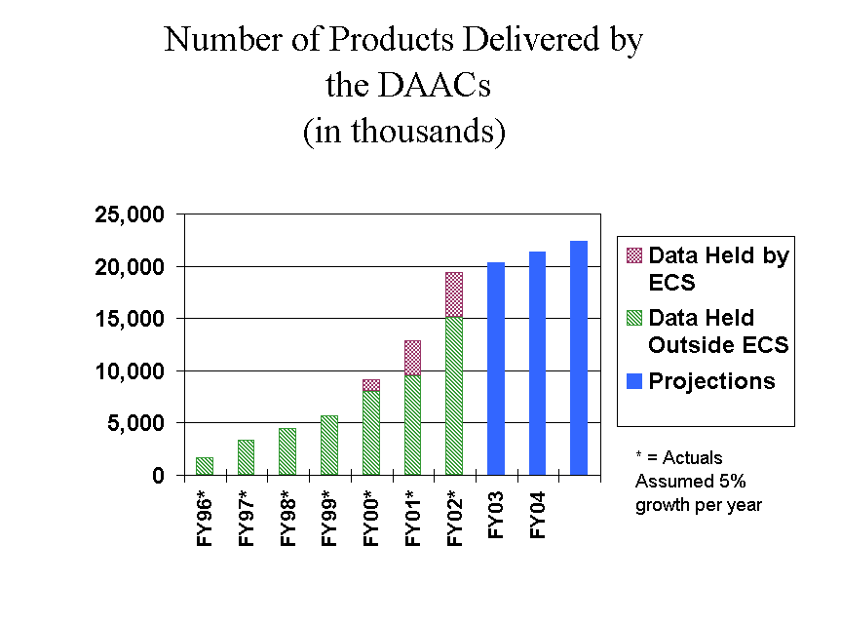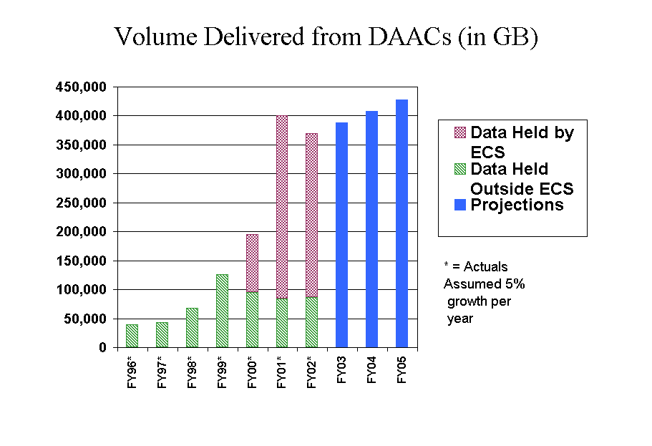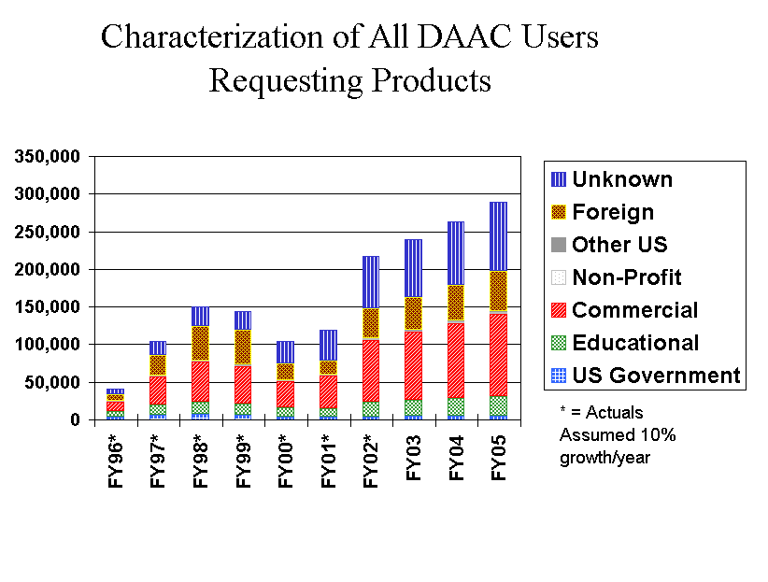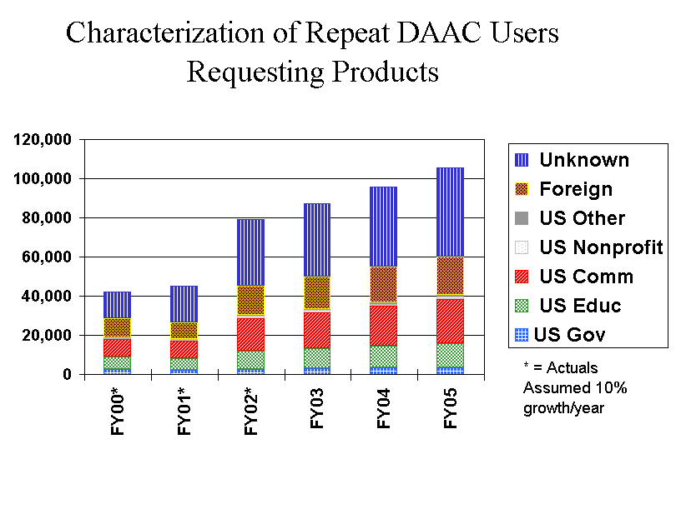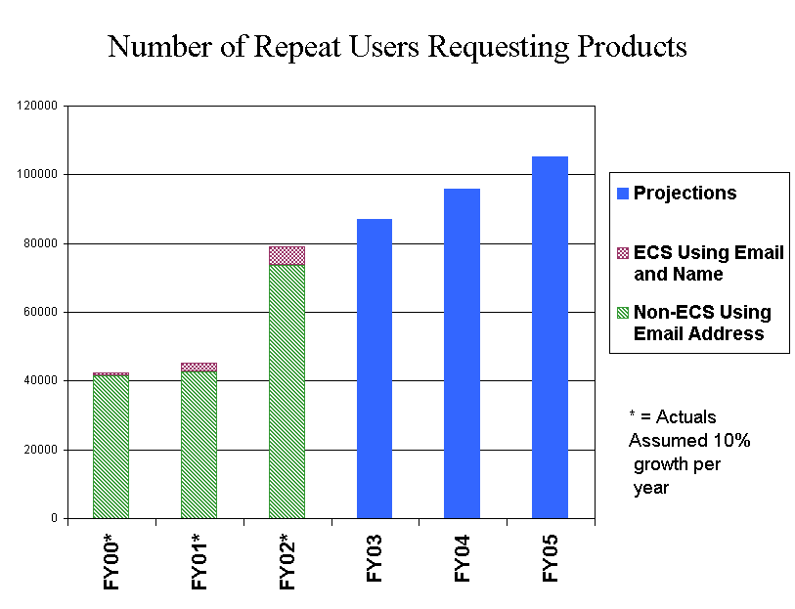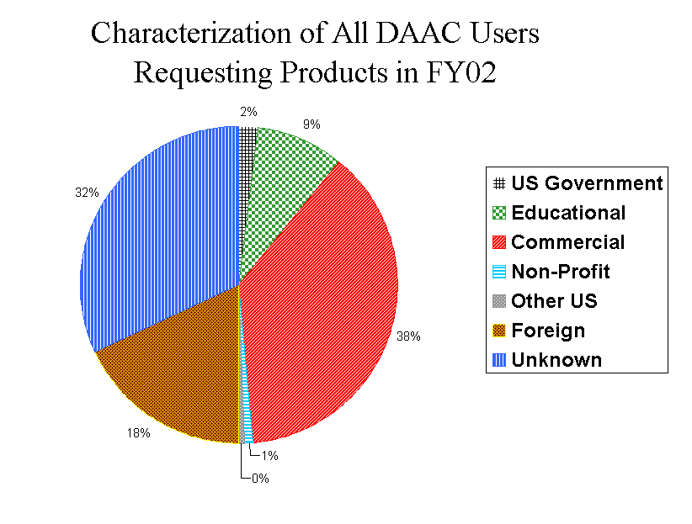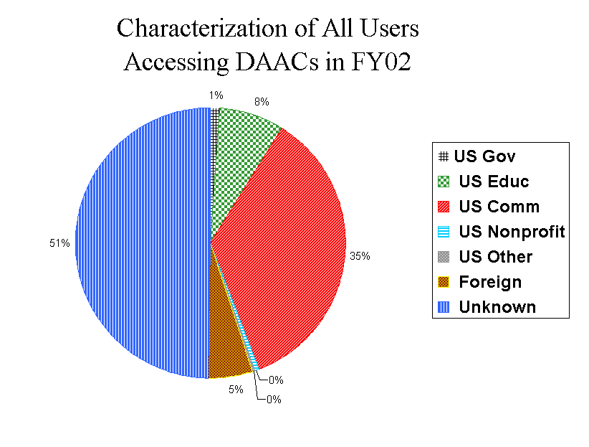

DAAC Fiscal Year 2002 Access Statistics for Non-ECS Data
Number of Distinct Users Accessing DAACs
TITLE | ASF | EDC | GHRC | GSFC | JPL | LARC | NSIDC | ORNL | SEDAC |  | TOTAL
EDG (users) |  |  |  |  |  |  |  |  |  |  | 39,960
Local IMS (users) | 0 | 0 | 4,455 | 0 | 0 | 0 | 0 | 0 | 0 |  | 4,455
WWW (users) | 110,870 | 217,125 | 167,968 | 410,705 | 117,752 | 110,219 | 139,881 | 137,931 | 718,834 |  | 2,131,285
FTP (users) | 60 | 4,179 | 390 | 2,230 | 1,882 | 0 | 797 | 323 | 1,500 |  | 11,361
Off-line (users) | 0 | 5,027 | 346 | 0 | 1,682 | 0 | 2,150 | 2,186 | 0 |  | 11,391
Total (users) | 110,930 | 226,331 | 173,159 | 412,935 | 121,316 | 110,219 | 142,828 | 140,440 | 720,334 |  | 2,198,452
Number of Accesses
TITLE | ASF | EDC | GHRC | GSFC | JPL | LARC | NSIDC | ORNL | SEDAC |  | TOTAL
EDG (accesses) |  |  |  |  |  |  |  |  |  |  | 240,463
Local IMS (accesses) | 0 | 0 | 5,709 | 0 | 0 | 0 | 0 | 0 | 0 |  | 5,709
WWW Inquiries | 219,644 | 408,663 | 451,571 | 792,109 | 284,260 | 190,922 | 246,275 | 262,474 | 1,502,557 |  | 4,358,475
WWW Data Retrievals | 23,623 | 23,108 | 268 | 198,428 | 0 | 0 | 0 | 1,783 | 21,648 |  | 268,858
FTP (accesses) | 245 | 13,022 | 12,855 | 13,159 | 15,971 | 0 | 6,383 | 2,135 | 6,128 |  | 69,898
Off-line (accesses) | 0 | 5,027 | 346 | 0 | 1,682 | 0 | 2,150 | 2,186 | 0 |  | 11,391
Total (accesses) | 243,512 | 449,820 | 470,749 | 1,003,696 | 301,913 | 190,922 | 254,808 | 268,578 | 1,530,333 |  | 4,954,794
REQUESTS AND RETRIEVALS
Product Request Tracking and Delivery
TITLE | ASF | EDC | GHRC | GSFC | JPL | LARC | NSIDC | ORNL | SEDAC |  | TOTAL
Subscriptions Pending | 0 | 0 | 0 | 0 | 0 | 0 | 0 | 0 | 0 |  | 0
New Subscriptions | 0 | 0 | 6,379 | 387,525 | 5,784 | 0 | 0 | 0 | 0 |  | 399,688
Products Requested | 55,400 | 2,640 | 1,752,801 | 4,905,898 | 14,107 | 1,270,551 | 2,476 | 1,227 | 0 |  | 8,005,100
TOTAL NEW | 55,400 | 2,640 | 1,759,180 | 5,293,423 | 19,891 | 1,270,551 | 2,476 | 1,227 | 0 |  | 8,404,788
Products Delivered | 31,030 | 1,565 | 1,307,101 | 3,317,361 | 19,805 | 1,294,811 | 2,175 | 1,289 | 0 |  | 5,975,137

Request Turnaround
Rejected by User | 0 | 0 | 0 | 0 | 99 | 0 | 0 | 0 | 0 |  | 99
Cancellations | 7,483 | 0 | 551,450 | 1,608,161 | 0 | 0 | 0 | 0 | 0 |  | 2,167,094
Average for Requested Products (days) | 6 | 5 | 5 | 4 | 3 | 6 | 2 | 0 | 0 |  | 4
Maximum (days) | 805 | 274 | 50 | 1,382 | 150 | 34 | 33 | 0 | 0 |  | 1,382
Average for All Deliveries (days) | 2 | 0 | 2 | 2 | 0 | 6 | 0 | 0 | 0 |  | 1
Anonymous FTP and WWW Retrievals
FTP Product Retrievals | 15,954 | 176,894 | 1,308,341 | 2,635,357 | 3,115,469 | 0 | 268,641 | 56,862 | 208,034 |  | 7,785,552
WWW Product Retrievals | 67,757 | 455,429 | 12,729 | 778,263 | 0 | 0 | 0 | 27,522 | 55,269 |  | 1,396,969
TOTAL PRODUCTS DELIVERED | 114,741 | 633,888 | 2,628,171 | 6,730,981 | 3,135,274 | 1,294,811 | 270,816 | 85,673 | 263,303 |  | 15,157,658
System IMS Sessions Requesting Products
EDG |  |  |  |  |  |  |  |  |  |  | 26,063

Volume Delivered by DAACs (MB)
TITLE | ASF | EDC | GHRC | GSFC | JPL | LARC | NSIDC | ORNL | SEDAC |  | TOTAL
FTP (MB) | 720,149 | 36,377 | 1,286,883 | 10,961,610 | 0 | 6,062,302 | 0 | 0 | 0 |  | 19,067,321
Anon FTP (MB) | 61,062 | 1,449,188 | 1,248,602 | 7,649,177 | 3,514,078 | 0 | 242,287 | 30,047 | 174,872 |  | 14,369,313
WWW (MB) | 6,659 | 955,762 | 6,278 | 49,316 | 0 | 0 | 0 | 297 | 2,818 |  | 1,021,130
8mm (MB) | 80,761 | 181,357 | 1,513,846 | 15,128,048 | 7,749,227 | 465,737 | 0 | 0 | 0 |  | 25,118,976
4mm (MB) | 0 | 0 | 116,064 | 3,076,805 | 0 | 4,892 | 0 | 0 | 0 |  | 3,197,761
9 track (MB) | 0 | 0 | 0 | 0 | 0 | 0 | 0 | 0 | 0 |  | 0
DLT (MB) | 191,006 | 0 | 271,809 | 4,777,782 | 8,437,404 | 147,272 | 0 | 0 | 0 |  | 13,825,273
CD ROM (MB) | 919,215 | 410,107 | 74,691 | 578,946 | 7,441,287 | 27,939 | 0 | 1,469,885 | 0 |  | 10,922,070
CD Rec (MB) | 0 | 0 | 0 | 0 | 388,673 | 0 | 0 | 0 | 0 |  | 388,673
Floppy (MB) | 0 | 0 | 0 | 0 | 0 | 0 | 0 | 0 | 0 |  | 0
DVD (MB) | 0 | 1,465 | 0 | 0 | 0 | 0 | 0 | 0 | 0 |  | 1,465
Unknown (MB) | 0 | 1,953 | 0 | 564,391 | 0 | 0 | 0 | 27,300 | 0 |  | 593,644
Total Digital (MB) | 1,978,852 | 3,036,209 | 4,518,173 | 42,786,075 | 27,530,669 | 6,708,142 | 242,287 | 1,527,529 | 177,690 |  | 88,505,626
Deliveries by Types (Counts of Products)
TITLE | ASF | EDC | GHRC | GSFC | JPL | LARC | NSIDC | ORNL | SEDAC |  | TOTAL
FTP Retrievals (products) | 13,038 | 149 | 156,478 | 1,290,871 | 0 | 963,809 | 1,328 | 0 | 0 |  | 2,425,673
Anon FTP Retrievals (products) | 15,954 | 176,894 | 1,308,341 | 2,635,357 | 3,115,469 | 0 | 268,641 | 56,862 | 208,034 |  | 7,785,552
WWW Retrievals (products) | 67,757 | 455,429 | 12,729 | 778,263 | 0 | 0 | 0 | 27,522 | 55,269 |  | 1,396,969
8mm (products) | 13,210 | 572 | 231,613 | 1,394,435 | 3,583 | 140,196 | 3 | 0 | 0 |  | 1,783,612
4mm (products) | 0 | 0 | 31,192 | 502,271 | 0 | 2,436 | 0 | 0 | 0 |  | 535,899
9 track (products) | 0 | 0 | 0 | 0 | 0 | 0 | 0 | 0 | 0 |  | 0
DLT (products) | 3,872 | 0 | 5,855 | 120,860 | 275 | 51,282 | 0 | 0 | 0 |  | 182,144
CD ROM (products) | 910 | 830 | 10,486 | 287 | 14,802 | 137,028 | 348 | 1,037 | 0 |  | 165,728
CD Rec (products) | 0 | 0 | 0 | 0 | 657 | 0 | 0 | 0 | 0 |  | 657
Floppy (products) | 0 | 0 | 0 | 0 | 0 | 0 | 0 | 1 | 0 |  | 1
DVD (products) | 0 | 6 | 0 | 0 | 0 | 0 | 0 | 0 | 0 |  | 6
Unknown (products) | 0 | 8 | 871,427 | 6,183 | 0 | 56 | 423 | 250 | 0 |  | 878,347
Total Deliveries (products) | 114,741 | 633,888 | 2,628,121 | 6,728,527 | 3,134,786 | 1,294,807 | 270,743 | 85,672 | 263,303 |  | 15,154,588

Non-Digital Product Units Delivered by DAACs
TITLE | ASF | EDC | GHRC | GSFC | JPL | LARC | NSIDC | ORNL | SEDAC |  | TOTAL
Paper | 0 | 0 | 0 | 2,454 | 0 | 0 | 72 | 0 | 0 |  | 2,526
Film | 0 | 0 | 0 | 0 | 0 | 0 | 1 | 0 | 0 |  | 1
Video | 0 | 0 | 50 | 0 | 488 | 4 | 0 | 1 | 0 |  | 543
Volumes Delivered by Request Source (MB)
TITLE | ASF | EDC | GHRC | GSFC | JPL | LARC | NSIDC | ORNL | SEDAC |  | TOTAL
System IMS (MB) | 0 | 0 | 38,493 | 0 | 0 | 0 | 0 | 0 | 0 |  | 38,493
Local IMS (MB) | 0 | 0 | 1,193,789 | 0 | 0 | 0 | 0 | 0 | 0 |  | 1,193,789
DOTS (MB) | 991,917 | 631,259 | 0 | 11,416,238 | 0 | 0 | 0 | 10,349 | 0 |  | 13,049,763
E-mail (MB) | 0 | 0 | 1,647,643 | 2,903,440 | 7,191,859 | 0 | 0 | 23,406 | 0 |  | 11,766,348
FAX (MB) | 0 | 0 | 0 | 0 | 0 | 0 | 0 | 0 | 0 |  | 0
Phone (MB) | 0 | 0 | 50,158 | 0 | 677,218 | 0 | 0 | 0 | 0 |  | 727,376
Walk-in (MB) | 0 | 0 | 33,817 | 0 | 296,690 | 0 | 0 | 2,588 | 0 |  | 333,095
WWW.(MB) | 0 | 0 | 0 | 20,767,904 | 0 | 6,708,142 | 0 | 1,462,124 | 0 |  | 28,938,170
Mail (MB) | 919,215 | 0 | 0 | 0 | 1,019 | 0 | 0 | 0 | 0 |  | 920,234
Subscription (MB) | 0 | 0 | 299,393 | 0 | 15,849,806 | 0 | 0 | 0 | 0 |  | 16,149,199
Unknown.(MB) | 0 | 0 | 0 | 0 | 0 | 0 | 0 | 0 | 0 |  | 0
Anon FTP.(MB) | 61,062 | 1,449,188 | 1,248,602 | 7,649,177 | 3,514,078 | 0 | 242,287 | 30,047 | 174,872 |  | 14,369,313
WWW Retrievals (MB) | 6,659 | 955,762 | 6,278 | 49,316 | 0 | 0 | 0 | 297 | 2,818 |  | 1,021,130
Total Volume (MB) | 1,978,853 | 3,036,209 | 4,518,173 | 42,786,075 | 27,530,670 | 6,708,142 | 242,287 | 1,528,811 | 177,690 |  | 88,506,910

Deliveries by Request Source
TITLE | ASF | EDC | GHRC | GSFC | JPL | LARC | NSIDC | ORNL | SEDAC |  | TOTAL
System IMS (counts) | 0 | 0 | 815 | 0 | 0 | 0 | 0 | 0 | 0 |  | 815
Local IMS (counts) | 0 | 0 | 1,023,207 | 0 | 0 | 0 | 0 | 0 | 0 |  | 1,023,207
DOTS (counts) | 30,120 | 1,565 | 0 | 980,882 | 0 | 0 | 0 | 11 | 0 |  | 1,012,578
E-mail (counts) | 0 | 0 | 215,095 | 88,199 | 11,626 | 0 | 383 | 11 | 0 |  | 315,314
FAX (counts) | 0 | 0 | 0 | 0 | 0 | 0 | 2 | 0 | 0 |  | 2
Phone (counts) | 0 | 0 | 1,749 | 0 | 1,494 | 0 | 26 | 0 | 0 |  | 3,269
Walk-in (counts) | 0 | 0 | 3,398 | 0 | 719 | 0 | 1,758 | 2 | 0 |  | 5,877
WWW (counts) | 0 | 0 | 0 | 2,248,280 | 0 | 1,294,811 | 0 | 1,265 | 0 |  | 3,544,356
Mail (counts) | 910 | 0 | 0 | 0 | 3 | 0 | 6 | 0 | 0 |  | 919
Subscription (counts) | 0 | 0 | 62,837 | 0 | 5,963 | 0 | 0 | 0 | 0 |  | 68,800
Unknown.(counts) | 0 | 0 | 0 | 0 | 0 | 0 | 0 | 0 | 0 |  | 0
Anon FTP Retrievals.(counts) | 15,954 | 176,894 | 1,308,341 | 2,635,357 | 3,115,469 | 0 | 268,641 | 56,862 | 208,034 |  | 7,785,552
WWW Retrievals.(counts) | 67,757 | 455,429 | 12,729 | 778,263 | 0 | 0 | 0 | 27,522 | 55,269 |  | 1,396,969
Total Deliveries.(counts) | 114,741 | 633,888 | 2,628,171 | 6,730,981 | 3,135,274 | 1,294,811 | 270,816 | 85,673 | 263,303 |  | 15,157,658
NEW USERS REQUESTING AND RETRIEVING PRODUCTS
New Users Requesting Products Via IMS, Off-line, or WWW Order System, or Retrieving Via FTP
TITLE | ASF | EDC | GHRC | GSFC | JPL | LARC | NSIDC | ORNL | SEDAC | GCMD | TOTAL
US Government | 10 | 125 | 32 | 207 | 386 | 23 | 63 | 24 | 11 | 0 | 881
Educational | 38 | 272 | 100 | 348 | 651 | 50 | 234 | 86 | 148 | 0 | 1,927
Commercial | 28 | 1,004 | 70 | 435 | 6,640 | 49 | 212 | 106 | 415 | 0 | 8,959
Non-Profit | 3 | 61 | 3 | 28 | 174 | 1 | 33 | 15 | 71 | 0 | 389
Other USA | 1 | 55 | 6 | 34 | 51 | 1 | 11 | 10 | 16 | 0 | 185
Total USA | 80 | 1,517 | 211 | 1,052 | 7,902 | 124 | 553 | 241 | 661 | 0 | 12,341
Foreign | 52 | 1,379 | 128 | 794 | 633 | 100 | 366 | 197 | 318 | 0 | 3,967
Unknown | 3 | 643 | 56 | 112 | 148 | 0 | 52 | 23 | 122 | 0 | 1,159
Total | 135 | 3,539 | 395 | 1,958 | 8,683 | 224 | 971 | 461 | 1,101 | 0 | 17,467

New Users Retrieving Via WWW
TITLE | ASF | EDC | GHRC | GSFC | JPL | LARC | NSIDC | ORNL | SEDAC | GCMD | TOTAL
US Government | 203 | 33 | 0 | 938 | 0 | 0 | 0 | 26 | 63 | 0 | 1,263
Educational | 1,102 | 58 | 0 | 7,514 | 0 | 0 | 0 | 80 | 2,245 | 0 | 10,999
Commercial | 6,676 | 261 | 0 | 50,767 | 0 | 0 | 0 | 220 | 5,780 | 0 | 63,704
Non-Profit | 92 | 5 | 0 | 501 | 0 | 0 | 0 | 6 | 96 | 0 | 700
Other USA | 52 | 2 | 0 | 328 | 0 | 0 | 0 | 1 | 68 | 0 | 451
Total USA | 8,125 | 359 | 0 | 60,048 | 0 | 0 | 0 | 333 | 8,252 | 0 | 77,117
Foreign | 2,074 | 357 | 0 | 22,098 | 0 | 0 | 0 | 217 | 1,188 | 0 | 25,934
Unknown | 3,052 | 10,328 | 36 | 26,542 | 0 | 0 | 0 | 182 | 2,797 | 0 | 42,937
Total | 13,251 | 11,044 | 36 | 108,688 | 0 | 0 | 0 | 732 | 12,237 | 0 | 145,988
New Users Requesting or Retrieving Products - Union of Above
TITLE | ASF | EDC | GHRC | GSFC | JPL | LARC | NSIDC | ORNL | SEDAC | GCMD | TOTAL
US Government | 213 | 158 | 32 | 1,145 | 386 | 15 | 63 | 50 | 74 | 0 | 2,136
Educational | 1,140 | 330 | 100 | 7,862 | 651 | 40 | 234 | 166 | 2,393 | 0 | 12,916
Commercial | 6,704 | 1,265 | 70 | 51,202 | 6,640 | 34 | 212 | 326 | 6,195 | 0 | 72,648
Non-Profit | 95 | 66 | 3 | 529 | 174 | 0 | 33 | 21 | 167 | 0 | 1,088
Other USA | 53 | 57 | 6 | 362 | 51 | 1 | 11 | 11 | 84 | 0 | 636
Total USA | 8,205 | 1,876 | 211 | 61,100 | 7,902 | 90 | 553 | 574 | 8,913 | 0 | 89,424
Foreign | 2,126 | 1,736 | 128 | 22,892 | 633 | 79 | 366 | 414 | 1,506 | 0 | 29,880
Unknown | 3,055 | 10,971 | 92 | 26,654 | 148 | 0 | 52 | 205 | 2,919 | 0 | 44,096
Total | 13,386 | 14,583 | 431 | 110,646 | 8,683 | 169 | 971 | 1,193 | 13,338 | 0 | 163,400

ALL USERS REQUESTING AND RETRIEVING PRODUCTS
All Users Requesting Products Via IMS, Off-line, or WWW Order System, or Retrieving Via FTP
TITLE | ASF | EDC | GHRC | GSFC | JPL | LARC | NSIDC | ORNL | SEDAC | GCMD | TOTAL
US Government | 23 | 202 | 81 | 417 | 544 | 83 | 114 | 45 | 17 | 0 | 1,526
Educational | 73 | 367 | 157 | 656 | 866 | 119 | 377 | 128 | 187 | 0 | 2,930
Commercial | 39 | 1,222 | 103 | 586 | 7,025 | 63 | 283 | 145 | 538 | 0 | 10,004
Non-Profit | 6 | 86 | 8 | 46 | 192 | 2 | 43 | 23 | 91 | 0 | 497
Other USA | 1 | 63 | 7 | 41 | 60 | 5 | 16 | 13 | 23 | 0 | 229
Total USA | 142 | 1,940 | 356 | 1,746 | 8,687 | 272 | 833 | 354 | 856 | 0 | 15,186
Foreign | 66 | 1,757 | 198 | 1,331 | 997 | 174 | 514 | 280 | 453 | 0 | 5,770
Unknown | 20 | 800 | 93 | 205 | 239 | 0 | 108 | 61 | 191 | 0 | 1,717
Total | 228 | 4,497 | 647 | 3,282 | 9,923 | 446 | 1,455 | 695 | 1,500 | 0 | 22,673
All Users Retrieving Via WWW
TITLE | ASF | EDC | GHRC | GSFC | JPL | LARC | NSIDC | ORNL | SEDAC | GCMD | TOTAL
US Government | 485 | 64 | 0 | 1,865 | 0 | 0 | 0 | 54 | 162 | 0 | 2,630
Educational | 1,785 | 106 | 0 | 10,880 | 0 | 0 | 0 | 151 | 3,428 | 0 | 16,350
Commercial | 8,065 | 355 | 0 | 56,703 | 0 | 0 | 0 | 367 | 6,981 | 0 | 72,471
Non-Profit | 168 | 9 | 0 | 866 | 0 | 0 | 0 | 11 | 162 | 0 | 1,216
Other USA | 107 | 3 | 0 | 595 | 0 | 0 | 0 | 4 | 122 | 0 | 831
Total USA | 10,610 | 537 | 0 | 70,909 | 0 | 0 | 0 | 587 | 10,855 | 0 | 93,498
Foreign | 3,262 | 503 | 0 | 27,827 | 0 | 0 | 0 | 417 | 1,778 | 0 | 33,787
Unknown | 4,334 | 14,495 | 89 | 35,394 | 0 | 0 | 0 | 298 | 3,970 | 0 | 58,580
Total | 18,206 | 15,535 | 89 | 134,130 | 0 | 0 | 0 | 1,302 | 16,603 | 0 | 185,865

All Users Requesting or Retrieving Products - Union of Above
TITLE | ASF | EDC | GHRC | GSFC | JPL | LARC | NSIDC | ORNL | SEDAC | GCMD | TOTAL
US Government | 508 | 266 | 81 | 2,282 | 544 | 50 | 114 | 99 | 179 | 8,691 | 12,814
Educational | 1,858 | 473 | 157 | 11,536 | 866 | 82 | 377 | 279 | 3,615 | 13,973 | 33,216
Commercial | 8,104 | 1,577 | 103 | 57,289 | 7,025 | 39 | 283 | 512 | 7,519 | 79,384 | 161,835
Non-Profit | 174 | 95 | 8 | 912 | 192 | 1 | 43 | 34 | 253 | 1,717 | 3,429
Other USA | 108 | 66 | 7 | 636 | 60 | 2 | 16 | 17 | 145 | 0 | 1,057
Total USA | 10,752 | 2,477 | 356 | 72,655 | 8,687 | 174 | 833 | 941 | 11,711 | 103,765 | 212,351
Foreign | 3,328 | 2,260 | 198 | 29,158 | 997 | 118 | 514 | 697 | 2,231 | 43,825 | 83,326
Unknown | 4,354 | 15,295 | 182 | 35,599 | 239 | 0 | 108 | 359 | 4,161 | 56,150 | 116,447
Total | 18,434 | 20,032 | 736 | 137,412 | 9,923 | 292 | 1,455 | 1,997 | 18,103 | 203,740 | 412,124
REPEAT USERS REQUESTING AND RETRIEVING PRODUCTS
Repeat Users Requesting Products Via IMS, Off-line, or WWW Order System, or Retrieving Via FTP
TITLE | ASF | EDC | GHRC | GSFC | JPL | LARC | NSIDC | ORNL | SEDAC | GCMD | TOTAL
US Government | 17 | 105 | 64 | 292 | 232 | 81 | 69 | 27 | 7 | 0 | 894
Educational | 52 | 158 | 83 | 444 | 301 | 87 | 202 | 62 | 59 | 0 | 1,448
Commercial | 14 | 429 | 56 | 295 | 577 | 33 | 104 | 50 | 181 | 0 | 1,739
Non-Profit | 3 | 39 | 6 | 29 | 31 | 1 | 23 | 12 | 29 | 0 | 173
Other USA | 0 | 16 | 1 | 14 | 14 | 2 | 8 | 5 | 11 | 0 | 71
Total USA | 86 | 747 | 210 | 1,074 | 1,155 | 204 | 406 | 156 | 287 | 0 | 4,325
Foreign | 20 | 721 | 94 | 871 | 579 | 109 | 250 | 134 | 187 | 0 | 2,965
Unknown | 18 | 295 | 44 | 111 | 130 | 0 | 76 | 42 | 83 | 0 | 799
Total | 124 | 1,763 | 348 | 2,056 | 1,864 | 313 | 732 | 332 | 557 | 0 | 8,089

Repeat Users Retrieving Via WWW
TITLE | ASF | EDC | GHRC | GSFC | JPL | LARC | NSIDC | ORNL | SEDAC | GCMD | TOTAL
US Government | 376 | 52 | 0 | 1,241 | 0 | 0 | 0 | 43 | 125 | 0 | 1,837
Educational | 988 | 81 | 0 | 4,960 | 0 | 0 | 0 | 98 | 1,723 | 0 | 7,850
Commercial | 2,289 | 185 | 0 | 10,476 | 0 | 0 | 0 | 183 | 1,902 | 0 | 15,035
Non-Profit | 118 | 7 | 0 | 545 | 0 | 0 | 0 | 8 | 98 | 0 | 776
Other USA | 78 | 2 | 0 | 352 | 0 | 0 | 0 | 4 | 69 | 0 | 505
Total USA | 3,849 | 327 | 0 | 17,574 | 0 | 0 | 0 | 336 | 3,917 | 0 | 26,003
Foreign | 1,735 | 282 | 0 | 8,909 | 0 | 0 | 0 | 281 | 825 | 0 | 12,032
Unknown | 2,372 | 7,195 | 83 | 15,699 | 0 | 0 | 0 | 193 | 1,981 | 0 | 27,523
Total | 7,956 | 7,804 | 83 | 42,182 | 0 | 0 | 0 | 810 | 6,723 | 0 | 65,558
Repeat Users Requesting or Retrieving Products - Union of Above
TITLE | ASF | EDC | GHRC | GSFC | JPL | LARC | NSIDC | ORNL | SEDAC | GCMD | TOTAL
US Government | 393 | 157 | 64 | 1,533 | 232 | 42 | 69 | 70 | 132 | 0 | 2,692
Educational | 1,040 | 239 | 83 | 5,404 | 301 | 53 | 202 | 160 | 1,782 | 0 | 9,264
Commercial | 2,303 | 614 | 56 | 10,771 | 577 | 19 | 104 | 233 | 2,083 | 0 | 16,760
Non-Profit | 121 | 46 | 6 | 574 | 31 | 1 | 23 | 20 | 127 | 0 | 949
Other USA | 78 | 18 | 1 | 366 | 14 | 1 | 8 | 9 | 80 | 0 | 575
Total USA | 3,935 | 1,074 | 210 | 18,648 | 1,155 | 116 | 406 | 492 | 4,204 | 0 | 30,240
Foreign | 1,755 | 1,003 | 94 | 9,780 | 579 | 70 | 250 | 415 | 1,012 | 0 | 14,958
Unknown | 2,390 | 7,490 | 127 | 15,810 | 130 | 0 | 76 | 235 | 2,064 | 0 | 28,322
Total | 8,080 | 9,567 | 431 | 44,238 | 1,864 | 186 | 732 | 1,142 | 7,280 | 0 | 73,520
START | 10/01/2001
STOP | 09/30/2002

Top of Form
Total Number of Granules Ingested

ALL DAACs
2001-10-01 -- to -- 2002-09-30
2001-274 to 2002-273
Instrument | EDC | GSFC | LaRC | NSIDC | Totals
ACRIM |  |  | 3,798 |  | 3,798
AIRS |  | 309,017 |  |  | 309,017
AMSR |  |  |  | 86 | 86
AMSR-E |  | 134 |  | 8,039 | 8,173
AMSU |  | 51,215 |  |  | 51,215
ANCILLARY | 3,637 | 9,424 | 84 |  | 13,145
ASTER | 305,219 | 826 |  |  | 306,045
DAO |  | 9,058 | 1,002 |  | 10,060
FOS |  | 2,581 | 649 | 4 | 3,234
GLAS |  |  |  | 3,773 | 3,773
HSB |  | 44,811 |  |  | 44,811
LANDSAT-7 | 47,708 |  |  |  | 47,708
MISR | 8,176 |  | 51,657 |  | 59,833
MODIS | 2,295,229 | 7,743,364 |  | 756,488 | 10,795,081
MOPITT |  |  | 16,292 |  | 16,292
Other |  | 1 |  |  | 1
SAGE III |  |  | 1,673 |  | 1,673
SAGEIII |  |  | 5 |  | 5
SPACECRAFT |  | 35,252 | 9,251 |  | 44,503
SSMI |  | 355 | 348 | 1,304 | 2,007
SYSTEM | 424 | 1,605,491 | 4 | 5,803 | 1,611,722
TES |  |  | 3 |  | 3
Total | 2,660,393 | 9,811,529 | 84,766 | 775,497 | 13,332,185

Total Volume in MBytes Ingested

ALL DAACs
2001-10-01 -- to -- 2002-09-30
2001-274 to 2002-273
Instrument | EDC | GSFC | LaRC | NSIDC | Totals
ACRIM |  |  | 137 |  | 137
AIRS |  | 5,923,113 |  |  | 5,923,113
AMSR |  |  |  | 3,665 | 3,665
AMSR-E |  | 13 |  | 293,409 | 293,421
AMSU |  | 20,240 |  |  | 20,240
ANCILLARY | 127,910 | 148,068 | 1,331 |  | 277,309
ASTER | 32,053,145 | 64,916 |  |  | 32,118,061
DAO |  | 912,750 | 194,416 |  | 1,107,165
FOS |  | 37,921 | 619 | 37 | 38,577
GLAS |  |  |  | 215,354 | 215,354
HSB |  | 57,211 |  |  | 57,211
LANDSAT-7 | 49,844,112 |  |  |  | 49,844,112
MISR | 188,015 |  | 13,643,511 |  | 13,831,526
MODIS | 161,188,613 | 566,604,286 |  | 8,626,449 | 736,419,348
MOPITT |  |  | 276,654 |  | 276,654
Other
SAGE III |  |  | 20,937 |  | 20,937
SAGEIII
SPACECRAFT |  | 107,668 | 8,469 |  | 116,137
SSMI |  | 770 | 754 | 2,967 | 4,491
SYSTEM | 2,068 | 1,214,129 | 186 | 2,195 | 1,218,578
TES |  |  | 300 |  | 300
Total | 243,403,862 | 575,091,084 | 14,147,314 | 9,144,076 | 841,786,337

Generated: 12/12/2002

Top of Form
Total Number of Granules Archived

ALL DAACs
2001-10-01 -- to -- 2002-09-30
2001-274 to 2002-273
Instrument | EDC | GSFC | LaRC | NSIDC | Totals
ACRIM |  |  | 3,136 |  | 3,136
AIRS |  | 270,946 |  |  | 270,946
AMSR |  |  |  | 86 | 86
AMSR-E |  | 134 |  | 7,977 | 8,111
AMSU |  | 45,409 |  |  | 45,409
ANCILLARY | 3,779 | 19,796 | 4,432 |  | 28,007
ASTER | 531,708 | 827 |  |  | 532,535
DAO |  | 8,137 | 1,121 |  | 9,258
FOS |  | 2,581 | 614 | 4 | 3,199
GLAS |  |  |  | 3,715 | 3,715
HSB |  | 39,448 |  |  | 39,448
LANDSAT-7 | 295,523 |  |  |  | 295,523
MISR | 8,178 |  | 1,134,741 |  | 1,142,919
MODIS | 2,259,775 | 7,513,875 | 3 | 756,655 | 10,530,308
MOPITT |  |  | 16,198 |  | 16,198
Other |  | 10,147 |  |  | 10,147
SAGE III |  |  | 1,112 |  | 1,112
SPACECRAFT |  | 50,960 | 30,911 |  | 81,871
SSMI |  | 381 | 394 | 1,304 | 2,079
SYSTEM | 1,859 | 4,176 | 3,436 | 5,797 | 15,268
TES |  |  | 3 |  | 3
Total | 3,100,822 | 7,966,817 | 1,196,101 | 775,538 | 13,039,278

Total Volume in MBytes Archived

ALL DAACs
2001-10-01 -- to -- 2002-09-30
2001-274 to 2002-273
Instrument | EDC | GSFC | LaRC | NSIDC | Totals
ACRIM |  |  | 131 |  | 131
AIRS |  | 5,542,291 |  |  | 5,542,291
AMSR |  |  |  | 3,842 | 3,842
AMSR-E |  | 13 |  | 305,911 | 305,924
AMSU |  | 17,182 |  |  | 17,182
ANCILLARY | 142,598 | 625,787 | 3,357 |  | 771,743
ASTER | 39,391,737 | 68,069 |  |  | 39,459,807
DAO |  | 850,425 | 221,049 |  | 1,071,474
FOS |  | 39,759 | 166 | 39 | 39,964
GLAS |  |  |  | 225,759 | 225,759
HSB |  | 51,515 |  |  | 51,515
LANDSAT-7 | 52,772,459 |  |  |  | 52,772,459
MISR | 196,738 |  | 123,539,783 |  | 123,736,522
MODIS | 167,565,178 | 577,246,149 | 1 | 9,035,522 | 753,846,850
MOPITT |  |  | 286,227 |  | 286,227
Other |  | 93,054 |  |  | 93,054
SAGE III |  |  | 21,650 |  | 21,650
SPACECRAFT |  | 114,989 | 17,425 |  | 132,414
SSMI |  | 847 | 876 | 2,897 | 4,621
SYSTEM | 4,247 | 77,627 | 16,358 | 2,301 | 100,533
TES |  |  | 315 |  | 315
Total | 260,072,958 | 584,727,709 | 124,107,337 | 9,576,271 | 978,484,275

Generated: 12/12/2002
Top of Form
Total Number of Granules Retrieved from Archive

ALL DAACs
2001-10-01 -- to -- 2002-09-30
2001-274 to 2002-273
Instrument | EDC | GSFC | LaRC | NSIDC | Latis | Totals
ACRIM |  |  | 488 |  |  | 488
ACRIM II |  |  |  |  | 3 | 3
AERONET |  |  |  |  | 10 | 10
AIRMISR |  |  |  |  | 856 | 856
AIRS |  | 111,620 |  |  |  | 111,620
AMSR-E |  | 196 |  | 3,510 |  | 3,706
AMSU |  | 38,143 |  |  |  | 38,143
ANCILLARY | 5,232 | 81,211 | 20,195 |  |  | 106,638
ASTER | 1,312,270 | 1,207 |  |  |  | 1,313,477
B3 |  |  |  |  | 73,738 | 73,738
CERES |  |  |  |  | 54,930 | 54,930
CSU |  |  |  |  | 20 | 20
D1 |  |  |  |  | 69,863 | 69,863
D1_NAT |  |  |  |  | 469,272 | 469,272
D2 |  |  |  |  | 3,626 | 3,626
D2_NAT |  |  |  |  | 29,092 | 29,092
DAO |  | 17,124 | 1,911 |  |  | 19,035
DX |  |  |  |  | 524,704 | 524,704
ECMWF |  |  |  |  | 1 | 1
ELECTRA |  |  |  |  | 29 | 29
ERB-Scanner |  |  |  |  | 617 | 617
ERBE |  |  |  |  | 112,946 | 112,946
ERBE-Nonscanner |  |  |  |  | 7,824 | 7,824
ERBE-Scanner |  |  |  |  | 1,690 | 1,690
ERBE-Scanner,ERBE-No |  |  |  |  | 12,095 | 12,095
FIRE |  |  |  |  | 103,870 | 103,870
FOS |  | 184 | 2,428 |  |  | 2,612
FUNCHAL |  |  |  |  | 11 | 11
G-meter |  |  |  |  | 21 | 21
GLAS |  |  |  | 160 |  | 160
GOES-8 |  |  |  |  | 100 | 100
GTE |  |  |  |  | 221,960 | 221,960
HSB |  | 26,385 |  |  |  | 26,385
ICESNOW |  |  |  |  | 3 | 3
IMAU |  |  |  |  | 28 | 28
ISCCP |  |  |  |  | 45,630 | 45,630
IWV |  |  |  |  | 2 | 2
KINGAIR |  |  |  |  | 30 | 30
LANDSAT-7 | 11,601 |  |  |  |  | 11,601
LIDAR |  |  |  |  | 2,694 | 2,694
MAGE |  |  |  |  | 1 | 1
MALBAL |  |  |  |  | 42 | 42
MAS |  |  |  |  | 133 | 133
MCRW |  |  |  |  | 19 | 19
MET_STATION |  |  |  |  | 16 | 16
MIR |  |  |  |  | 1 | 1
MISR | 10 |  | 1,570,389 |  | 1,820 | 1,572,219
Model |  |  |  |  | 33 | 33
MODIS | 489,756 | 4,812,718 | 28 | 63,326 |  | 5,365,828
MOPITT |  |  | 32,021 |  |  | 32,021
MULTIPLE | 1,233 | 1,588 | 661 | 2 |  | 3,484
NCAR_C-130 |  |  |  |  | 2 | 2
NEXRAD |  |  |  |  | 1 | 1
OCEANS |  |  |  |  | 38 | 38
OSTA3 |  |  |  |  | 3 | 3
OTHER |  | 1 |  |  | 3,654 | 3,655
PAMS |  |  |  |  | 12 | 12
PDL |  |  |  |  | 27 | 27
PM2.5 |  |  |  |  | 1 | 1
POAM2 |  |  |  |  | 155 | 155
PORSAN |  |  |  |  | 58 | 58
PSU |  |  |  |  | 55 | 55
PW |  |  |  |  | 913 | 913
RADIOSONDE |  |  |  |  | 366 | 366
RAMAN_LIDAR |  |  |  |  | 28 | 28
RAWINSONDE |  |  |  |  | 33 | 33
SABRELINER |  |  |  |  | 37 | 37
SAGE III |  |  | 932 |  |  | 932
SAGE1 |  |  |  |  | 154 | 154
SAGE2 |  |  |  |  | 324,826 | 324,826
SAGEIII |  |  | 6 |  |  | 6
SAM2 |  |  |  |  | 10,411 | 10,411
SANMAR |  |  |  |  | 62 | 62
SMPS |  |  |  |  | 23 | 23
SOF |  |  |  |  | 27 | 27
Solar Monitor |  |  |  |  | 7 | 7
SPACECRAFT |  | 72,202 | 42,238 |  |  | 114,440
SRB |  |  |  |  | 4,100 | 4,100
SRL1 |  |  |  |  | 51 | 51
SRL2 |  |  |  |  | 38 | 38
SSMI |  | 3,352 | 2 | 1,518 | 784 | 5,656
SUNP |  |  |  |  | 25 | 25
SUROIT |  |  |  |  | 19 | 19
SW |  |  |  |  | 246 | 246
SW_LW |  |  |  |  | 2,605 | 2,605
SYSTEM | 7,951 | 4,018 | 249,836 | 3,891 |  | 265,696
TOVS |  |  |  |  | 545 | 545
UKMO_C130 |  |  |  |  | 30 | 30
UND_CITATION |  |  |  |  | 1 | 1
UW_C131A |  |  |  |  | 41 | 41
UW_CV-580 |  |  |  |  | 24 | 24
VALDIVA |  |  |  |  | 26 | 26
Total | 1,828,053 | 5,169,949 | 1,921,135 | 72,407 | 2,087,158 | 11,078,702

Total Volume in MBytes Retrieved from Archive

ALL DAACs
2001-10-01 -- to -- 2002-09-30
2001-274 to 2002-273
Instrument | EDC | GSFC | LaRC | NSIDC | Latis | Totals
ACRIM |  |  | 1,165 |  |  | 1,165
ACRIM II
AERONET |  |  |  |  | 1 | 1
AIRMISR |  |  |  |  | 18,555 | 18,555
AIRS |  | 6,303,927 |  |  |  | 6,303,927
AMSR-E |  | 1,648 |  | 271,705 |  | 273,353
AMSU |  | 338,223 |  |  |  | 338,223
ANCILLARY | 259,665 | 1,659,845 | 142,329 |  |  | 2,061,839
ASTER | 131,912,554 | 102,431 |  |  |  | 132,014,986
B3 |  |  |  |  | 73,036 | 73,036
CERES |  |  |  |  | 4,102,795 | 4,102,795
CSU |  |  |  |  | 1 | 1
D1 |  |  |  |  | 748,689 | 748,689
D1_NAT |  |  |  |  | 605,691 | 605,691
D2 |  |  |  |  | 28,459 | 28,459
D2_NAT |  |  |  |  | 24,165 | 24,165
DAO |  | 1,640,838 | 306,999 |  |  | 1,947,837
DX |  |  |  |  | 779,829 | 779,829
ECMWF |  |  |  |  | 2 | 2
ELECTRA |  |  |  |  | 745 | 745
ERB-Scanner |  |  |  |  | 768 | 768
ERBE |  |  |  |  | 9,706 | 9,706
ERBE-Nonscanner |  |  |  |  | 45,317 | 45,317
ERBE-Scanner |  |  |  |  | 45,252 | 45,252
ERBE-Scanner,ERBE-No |  |  |  |  | 352,579 | 352,579
FIRE |  |  |  |  | 20,370 | 20,370
FOS |  | 3,112 | 16,474 |  |  | 19,586
FUNCHAL |  |  |  |  | 1 | 1
G-meter |  |  |  |  | 3 | 3
GLAS |  |  |  | 18,634 |  | 18,634
GOES-8 |  |  |  |  | 1 | 1
GTE |  |  |  |  | 53,506 | 53,506
HSB |  | 223,297 |  |  |  | 223,297
ICESNOW |  |  |  |  | 1 | 1
IMAU |  |  |  |  | 2 | 2
ISCCP |  |  |  |  | 35,372 | 35,372
IWV
KINGAIR |  |  |  |  | 216 | 216
LANDSAT-7 | 6,513,318 |  |  |  |  | 6,513,318
LIDAR |  |  |  |  | 107,635 | 107,635
MAGE
MALBAL |  |  |  |  | 9 | 9
MAS |  |  |  |  | 20,404 | 20,404
MCRW |  |  |  |  | 1 | 1
MET_STATION |  |  |  |  | 2 | 2
MIR |  |  |  |  | 4 | 4
MISR | 304 |  | 97,188,026 |  | 1,449 | 97,189,779
Model |  |  |  |  | 138 | 138
MODIS | 42,459,499 | 547,418,338 | 324 | 1,051,357 |  | 590,929,518
MOPITT |  |  | 628,274 |  |  | 628,274
MULTIPLE | 363,556 | 725,160 | 134,021 | 44 |  | 1,222,781
NCAR_C-130 |  |  |  |  | 9 | 9
NEXRAD |  |  |  |  | 6 | 6
OCEANS |  |  |  |  | 6 | 6
OSTA3 |  |  |  |  | 1 | 1
OTHER |  | 36 |  |  | 51,019 | 51,055
PAMS |  |  |  |  | 9 | 9
PDL |  |  |  |  | 21 | 21
PM2.5
POAM2 |  |  |  |  | 59 | 59
PORSAN |  |  |  |  | 18 | 18
PSU |  |  |  |  | 9 | 9
PW |  |  |  |  | 10,891 | 10,891
RADIOSONDE |  |  |  |  | 1,293 | 1,293
RAMAN_LIDAR |  |  |  |  | 20 | 20
RAWINSONDE |  |  |  |  | 10 | 10
SABRELINER |  |  |  |  | 52 | 52
SAGE III |  |  | 2,217 |  |  | 2,217
SAGE1 |  |  |  |  | 310 | 310
SAGE2 |  |  |  |  | 28,677 | 28,677
SAGEIII
SAM2 |  |  |  |  | 13,095 | 13,095
SANMAR |  |  |  |  | 18 | 18
SMPS |  |  |  |  | 1 | 1
SOF |  |  |  |  | 1 | 1
Solar Monitor
SPACECRAFT |  | 541,650 | 311,215 |  |  | 852,866
SRB |  |  |  |  | 11,700 | 11,700
SRL1 |  |  |  |  | 152 | 152
SRL2 |  |  |  |  | 164 | 164
SSMI |  | 21,354 | 16 | 12,138 | 2,834 | 36,342
SUNP |  |  |  |  | 9 | 9
SUROIT |  |  |  |  | 2 | 2
SW |  |  |  |  | 967 | 967
SW_LW |  |  |  |  | 2,458 | 2,458
SYSTEM | 864,968 | 233,612 | 1,850,881 | 45,147 |  | 2,994,608
TOVS |  |  |  |  | 4,261 | 4,261
UKMO_C130 |  |  |  |  | 1,939 | 1,939
UND_CITATION |  |  |  |  | 1 | 1
UW_C131A |  |  |  |  | 53 | 53
UW_CV-580 |  |  |  |  | 145 | 145
VALDIVA |  |  |  |  | 6 | 6
Total | 182,373,863 | 559,213,472 | 100,581,943 | 1,399,024 | 7,204,919 | 850,773,222

Generated: 12/12/2002
Top of Form
Distribution to Users

ALL DAACs
2001-10-01 -- to -- 2002-09-30
2001-274 to 2002-273
Metrics Provider | # Orders | # Requests | # Granules | # files | # Mbytes
EDC | 45,764 | 1,230,297 | 1,754,107 | 4,341,000 | 174,552,672
GSFC | 25,663 | 214,455 | 682,849 | 1,767,722 | 58,964,071
LaRC | 4,865 | 699,546 | 768,118 | 1,862,428 | 50,941,123
Latis | 1,966 | 2,439 | 2,087,158 | 2,087,158 | 7,204,919
NSIDC | 1,452 | 10,046 | 68,259 | 170,853 | 1,256,128
ORNL | 106 | 125 | 461 |  | 239,458
Total | 79,816 | 2,156,908 | 5,360,952 | 10,229,161 | 293,158,371

Generated: 12/12/2002
Bottom of Form

Bottom of Form
Bottom of Form
Bottom of Form
